BSSE FINAL PROJECT

Software Development Plan

AI-Driven Internship Platform



Project Advisor

**Hira Asim**

Presented by:

**Group ID: F23SE040**

Student Reg# Student Name

L1F20BSSE0594 Hunain Murtaza

L1F20BSSE0558 Ahmed Khawar

L1F20BSSE0352 Yasir Ansar

**Faculty of Information Technology**

**University of Central Punjab**

Complete System

SDP Phase IV

AI-Driven Internship Platform

Advisor: Hira Asim

|  |  |
| --- | --- |
| Member Name | Primary Responsibility |
| Hunain Murtaza | Project Manager and Lead Developer |
| Ahmed Khawar | AI Specialist and Database Manager |
| Yasir Ansar | UX/UI Designer and Frontend Developer |

Table of Contents

Table of Contents i

Revision History iii

Abstract iv

1. Introduction 1

1.1 Product 1

1.2 Background 1

1.3 Objective(s)/Aim(s)/Target(s) 1

1.4 Scope 1

1.5 Business Goals 1

1.6 Document Conventions 1

1.7 Miscellaneous 1

2. Technical Architecture 2

2.1 Application and Data Architecture 2

2.1.1 Entity-Relation Diagram 4

2.1.2 Class Diagram 4

2.1.3 Activity Diagram 6

2.1.4 Component Diagram 7

2.2 Component Interactions and Collaborations 8

2.2.1 Collaboration Diagram 8

2.2.2 Event Trace Diagram 9

2.2.3 Sequence Diagrams 10

2.2.4 Skills Assessment 11

2.2.5 AI Based Manager 12

2.3 Design Reuse and Design Patterns 12

2.4 Technology Architecture 13

2.5 Architecture Evaluation 14

3. Detailed/Component Design 15

3.1 Component-Component Interface 16

3.2 Component-External Entities Interface 17

3.3 Component-Human Interface 18

4. Screenshots/Prototype 19

4.1 Workflow 19

4.2 Screens 20

4.2.1 Register 20

4.2.2 Complete Profile 20

4.2.3 Assessment Instructions 21

4.2.4 User Dashboard 22

4.2.5 User Profile 23

4.2.6 User Skills 24

4.2.7 User Internship 25

4.2.8 Organization Dashboard 26

4.2.9 Organization Manage Interns 26

4.2.10 Organization Send Offer 27

4.2.11 Admin Dashboard 27

5. Test Specification and Results 28

5.1 Test Case Specification 28

Summary of Test Results 33

6. Revised Project Plan 33

7. Project Completion Status 35

8. Deployment/Installation Guide 36

9. User Manual 36

10. References 38

11. Project Summary Form 39

Appendix A: Glossary 44

Appendix B: IV & V Report 45

Revision History

|  |  |  |  |
| --- | --- | --- | --- |
| **Name** | **Date** | **Reason For Changes** | **Version** |
| First Revision | 20-06-24 | More detailed diagrams | 1.0 |
| Second Revision | 28-06-24 | Upgrading screens according to functionalities | 2.0 |
| Third Revision | 02-07-24 | Checking Screens Functionalities | 3.0 |

# Abstract

The "AI-Driven Internship Platform" represents a significant advancement in bridging the academic and professional realms for computer science and software engineering students. By integrating sophisticated AI, including ChatGPT, the platform offers a dual approach to internships: students can engage in AI-driven projects, gaining hands-on experience by solving real-world problems under AI Manager guidance, or explore traditional internship opportunities. This platform not only connects students to suitable internship roles but also enhances their decision-making process by providing insights into the suitability and relevance of each opportunity. The platform stands out for its ability to adapt to individual student profiles, suggesting personalized opportunities based on their assessed skills and preferences. Additionally, its role in facilitating job offers and interviews adds a practical dimension to academic learning, significantly boosting employability. The "AI-Driven Internship Platform" thus serves as a comprehensive solution, preparing students for the dynamic demands of the tech industry and smoothing their transition from academic learning to professional application.

# Introduction

The AI-Driven Internship Platform revolutionizes the internship search for computer science and software engineering students who often face challenges in securing placements. Harnessing advanced AI technology like ChatGPT, the platform meticulously evaluates each student's unique skill set to identify internships that align perfectly with their capabilities. It offers two distinct pathways: AI-driven internships, where students receive guidance from an AI Manager, and traditional internships facilitated by a highly intelligent matching system. Essentially, it serves as a bridge between academic learning and practical job experiences, ensuring that students can seamlessly apply their classroom knowledge in real-world settings. The ultimate objective is to equip students with the skills and expertise needed to thrive in the tech industry, transforming theoretical concepts into tangible, marketable abilities that pave the way for successful career opportunities.

## Product

The "AI-Driven Internship Platform" aimed at alleviating the persistent challenges encountered by Computer Science and Software Engineering students when seeking internships. In response to the inherent complexities of the traditional internship acquisition pathway, characterized by limited industry connections, scarce opportunities, and intense competition, this project harnesses the power of Artificial Intelligence to seamlessly connect students with relevant internship placements. More than just a tool or application, the platform embodies a holistic solution, revolutionizing the internship acquisition process to empower students with practical skills and bolster their employability. Acting as a dynamic conduit between academic theory and real-world industry demands, it reshapes the landscape of internship opportunities in these specialized fields, offering students unprecedented access to meaningful experiential learning opportunities.

## Background

In the realm of academia and career advancement, the "AI-Driven Internship Platform" serves as a transformative tool for computer science students grappling with internship acquisition challenges. Traditionally, securing internships that align with one's skill set and academic background has been daunting, creating a gap between theoretical learning and practical application. This platform leverages advanced AI technology to bridge this gap by intelligently matching students with relevant internship opportunities. By offering both AI-driven and conventional internships, it provides a versatile pathway for students to gain hands-on experience and enhance their employability. Unlike conventional approaches, this platform emphasizes inclusivity, personalization, and accessibility, aiming to democratize internship access and empower students from diverse backgrounds to succeed in the competitive job market

## Objective(s)/Aim(s)/Target(s)

The objectives, aims, and targets of the "AI-Driven Internship Platform" project are as follows:

1. Develop an AI-driven skills assessment tool to evaluate students' technical proficiencies.
2. Create an AI-Based Manager to provide guidance and support to students throughout their internships.
3. Enable students to engage in AI-driven internships, where they work on AI-generated real-world problems.
4. Facilitate students in searching for external internship opportunities through the "Internship Matching Engine."
5. Improve the employability of students by providing them with practical experience that aligns with industry demands.

## Scope

The Design Test Specification (DTS) for the "AI-Driven Internship Platform" will focus on evaluating the effectiveness and functionality of each software component outlined in the Software Design Specification (SDS). This includes conducting thorough tests to ensure that the user registration system is intuitive and error-free, the AI-driven skills assessment tool accurately evaluates student skills, the internship options are presented seamlessly, the database management system operates efficiently, and the administrative tools are reliable. Additionally, the DTS will assess the overall user experience, ensuring that the platform meets usability standards and provides adequate support mechanisms for users. Through comprehensive testing procedures, the DTS aims to validate the design decisions and ensure that the final product meets the intended scope and requirements outlined in the SDS.

## Business Goals

The "AI-Driven Internship Platform" addresses several key business and corporate goals:

1. **Enhance Student Employability:**By providing practical experience and aligning it with industry demands, the platform contributes to preparing students for successful careers.
2. **Bridge the Academic-Industry Knowledge Gap:** The project promotes collaboration between educational institutions and external organizations, creating a dynamic ecosystem that benefits both students and employers.
3. **Improve the Quality of Higher Education:**The platform aims to revolutionize the internship experience, ensuring that students gain practical skills and experiences that enhance their academic journey.

## Document Conventions

Document conventions employed in this DTS include:

* **Section Headings:** Bold text for clear section separation.
* **Project Name:** "AI-Driven Internship Platform" consistently presented in title case and enclosed within quotation marks.
* **List Items:** Bulleted lists with bullet points for organized content presentation.
* **Hyperlinks:** Blue text and underlining for clickable hyperlinks.
* **File Names and Code:** Monospaced font for code snippets and file names.
* **User Interface Elements:** Bold text to distinguish user interface elements.
* **Quotations:** Enclosed within double quotation marks and indented for clarity.
* **Variables and Placeholders:** Italics within angled brackets for variables and placeholders.

## Miscellaneous

* **Meetings:** Regular updates for issue-solving.
* **Security:** Emphasize encryption and audits.
* **User Feedback:** Refine based on continuous user input.
* **Documentation:** Keep concise and updated records.
* **Testing:** Implement thorough testing.
* **Continuous Improvement:** Encourage ongoing innovation within the team

# Technical Architecture

The "AI-Driven Internship Platform" represents a custom-built solution aimed at revolutionizing the internship experience for users. With a focus on enhancing user engagement and simplifying the internship process, the platform incorporates key application components such as User/Student, Organization, Admin, AI-driven Internship Portal, AI Manager, and Internship Matching Engine. By leveraging advanced AI technology, the system efficiently manages user profiles, skills, skill assessments, internship options, feedback, and certificates. Operating through both batch and online processing modes, it ensures seamless interaction and data management. The platform adopts a client/server architecture, enabling access via web browsers for enhanced accessibility. At its core, the system is driven by the principles of skill assessment, internship recommendation, and AI-guided support through an AI Manager, culminating in the issuance of certificates and feedback submissions.

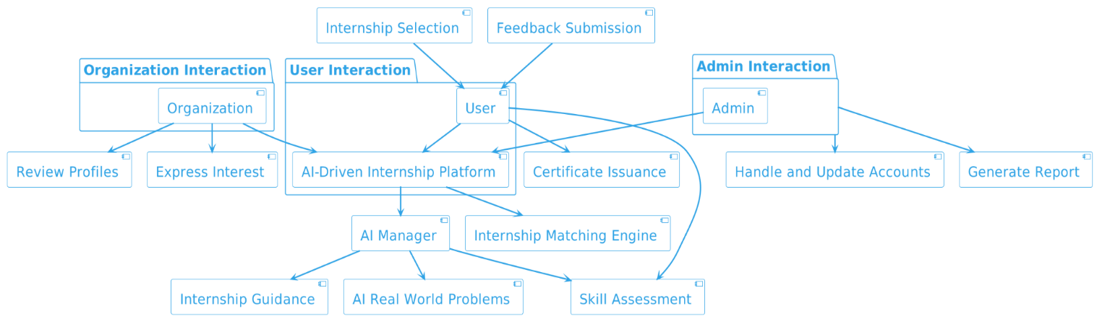**High-Level Architecture**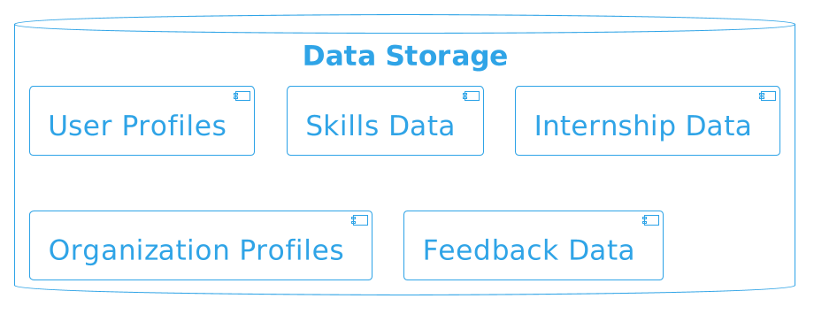

## Application and Data Architecture

The AI-Driven Internship Platform is a custom-built system designed to seamlessly connect students, organizations, and administrators, streamlining the internship process. It operates through a combination of batch and online processing, allowing users to register, log in, and engage in various activities. The major application components include:

**User/Student Module:**

* Manages user registration, login, and profile creation.
* Conducts skills assessments with categories for beginners, intermediates, and advanced users.
* Allows users to select suitable internship options, initiate internships, and obtain certificates upon completion.
* Provides a feedback mechanism for users.

**Organization Module:**

* Enables organizations to register, log in, and view shortlisted student profiles.
* Facilitates the expression of interest in potential interns.

**Admin Module:**

* Empower administrators to manage and update user accounts.

**AI-Driven Internship Portal:**

* Functions as the central orchestrator, managing skills assessments, internship options, and user accounts.
* Collaborates with the AI Manager for skills assessment, real-world problem provision, and guidance.
* Interfaces with the Internship Matching Engine for organization-student matching.

**AI Manager Module:**

* Evaluates skills assessments, provides real-world problems during internships, and guides students through their internship experience.

**Internship Matching Engine:**

* Facilitates the matching of organizations with suitable student profiles based on job descriptions.

### Entity-Relation Diagram

The ER diagram depicts the core components of the "AI-Driven Internship Platform." It includes entities like User, Organization, Internship, Feedback, Certificate, and Admin. Users engage in various activities, manage their profiles, and interact with Internships. Organizations offer Internships. Administrators oversee user-related activities. This visual representation provides a succinct overview of the system's structure and interactions.

### Class Diagram

The class diagram for the AI-driven internship Platform provides a static representation of the system's structure. It includes classes such as User, Organization, Admin, AI Manager, Internship, and Skill. Relationships like associations between classes, inheritance, and composition are captured. This diagram serves as a blueprint for the platform's architecture, highlighting the key entities, their attributes, and the associations that define their relationships.

### Activity Diagram

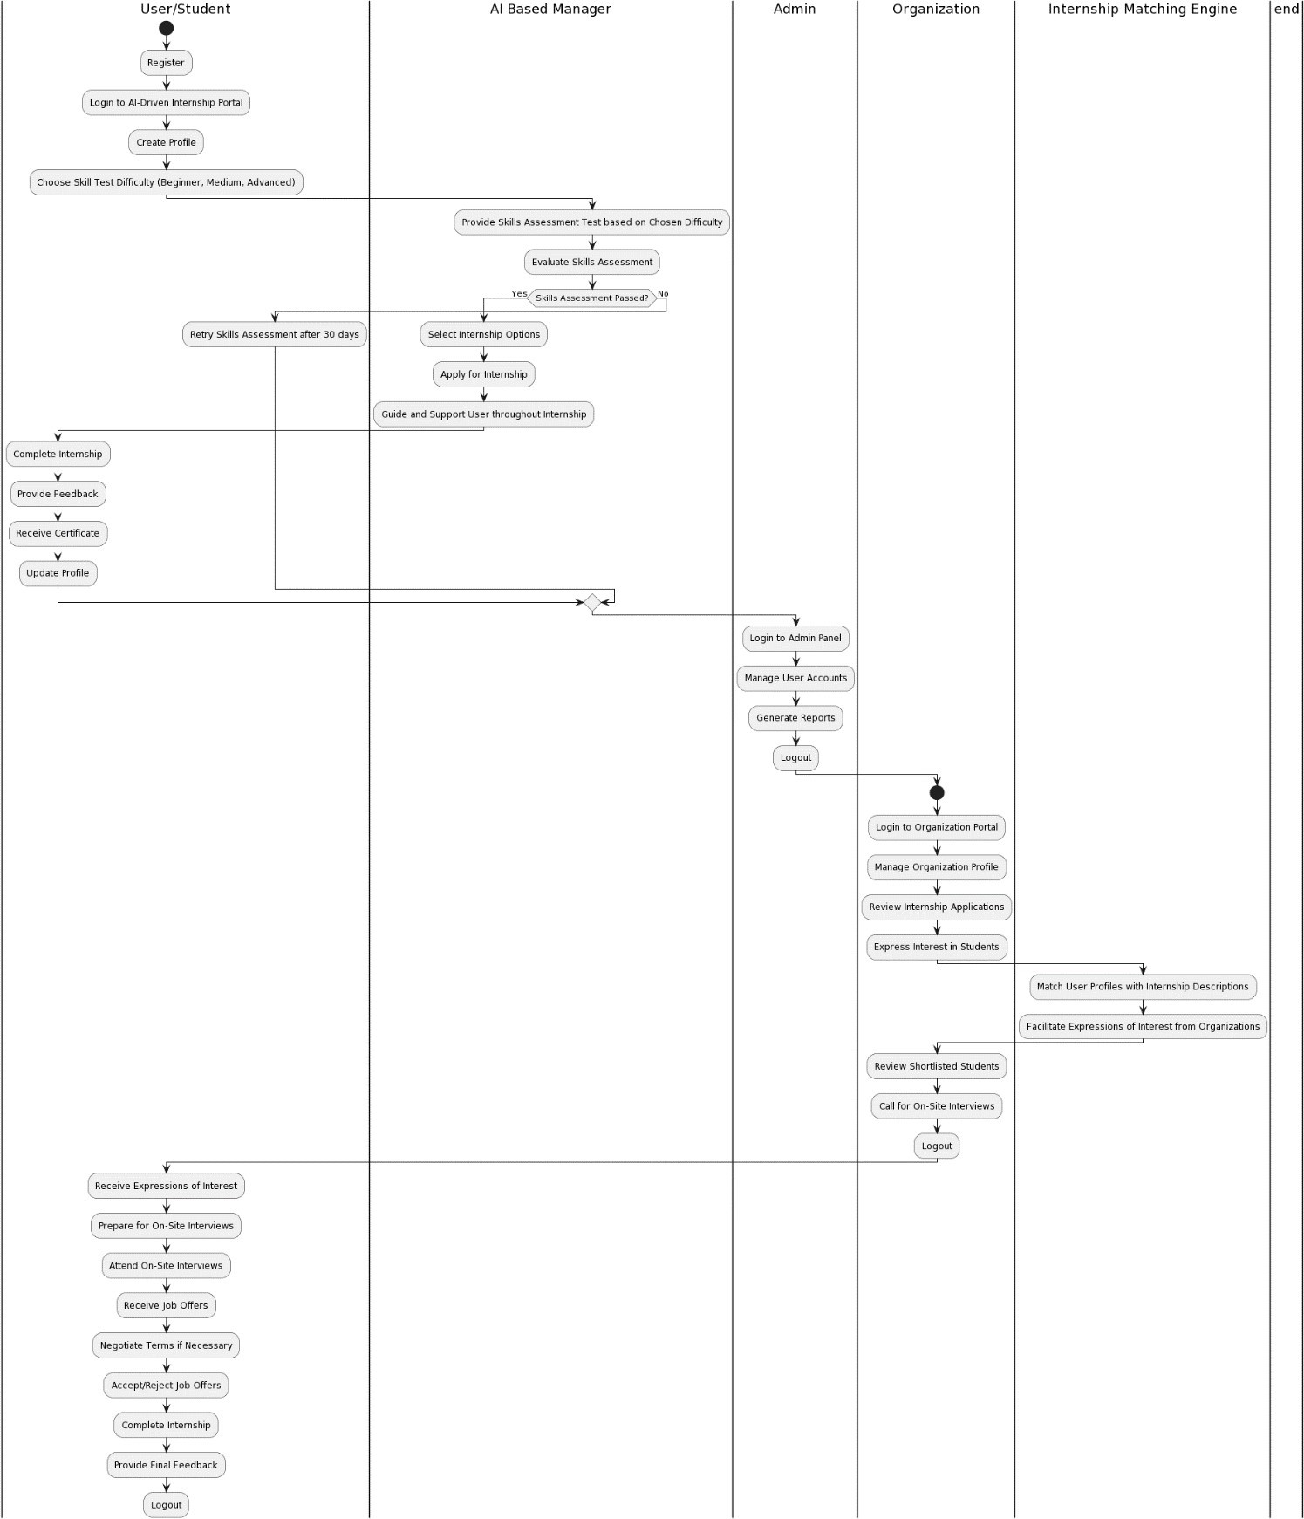

The activity diagram illustrates the sequential steps involved in the AI-Driven Internship Platform. Users begin by registering, creating profiles, and adding skills, followed by the selection of a skill test difficulty level (beginner, medium, or advanced). The AI-based manager then provides a tailored skills assessment test, evaluating the user's performance. If successful, users can apply for internships, guided by the AI Manager throughout the process. Upon completion, users receive certificates and update their profiles. The platform facilitates organizations in reviewing applications, expressing interest, and conducting on-site interviews. Users, upon receiving job offers, may negotiate terms, complete internships, and provide final feedback. Admin functions include managing user accounts.

### Component Diagram

The component diagram illustrates the primary components of the "AI-Driven Internship Platform" and their interactions. Users start by registering, creating profiles, and undergoing skill assessments. The AI-driven manager guides them through internships, and the platform facilitates updating profiles, providing feedback, and issuing certificates upon completion. Organizations utilize the Internship Matching Engine to review student profiles and express interest. The Admin component oversees system functionality.

## Component Interactions and Collaborations

### Collaboration Diagram

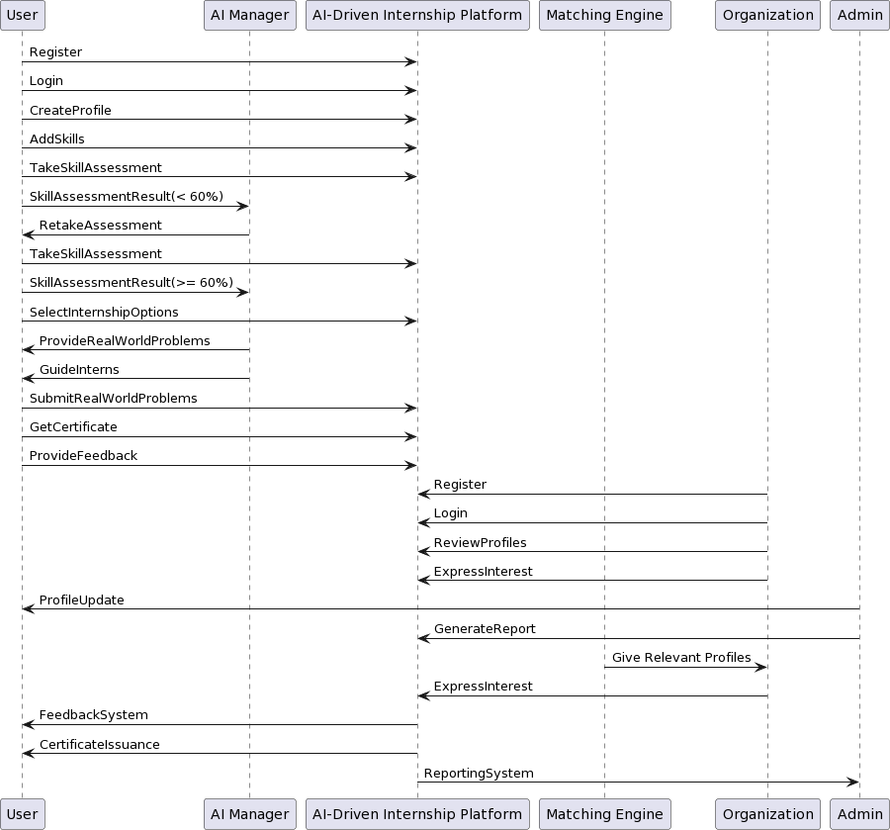

The collaboration diagram illustrates the dynamic interactions among key components and collaborations between different components in the AI-Driven Internship Platform. Users engage in a seamless process starting with registration, login, and skill assessment. If the assessment falls below 60%, users retry after 30 days. The AI Manager plays a crucial role, in evaluating assessments, guiding interns, and providing real-world problems during internships. Organizations interact by reviewing profiles and expressing interest. Admin generates reports on platform activities. The Internship Matching Engine facilitates connections between organizations and students. This visual representation captures the intricate collaboration, ensuring a comprehensive understanding of the platform's functionalities.

### Event Trace Diagram

The event trace diagram for the AI-driven internship Platform would illustrate the dynamic interactions between users, the AI Manager, the Internship Platform, and other components during specific scenarios. It would showcase how events unfold over time, depicting user registrations, logins, skills assessments, internship selections, AI Manager's guidance, and the completion of internships. This dynamic visualization helps in understanding the sequence of actions and communication flow within the platform.

### Sequence Diagrams

**User Registration**

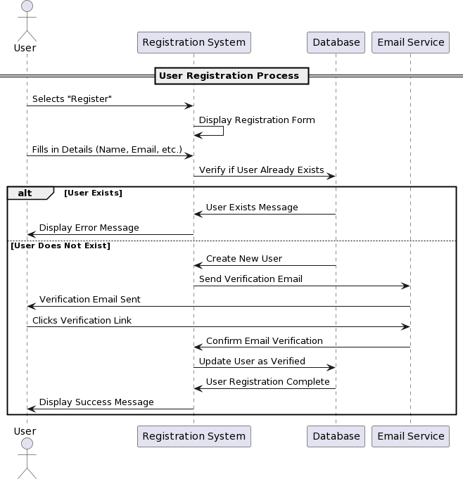

### Skills Assessment

### AI Based Manager

## Design Reuse and Design Patterns

During the development of the AI-Driven Internship Platform, several components and functionalities were designed with reusability in mind. The key areas of reuse include:

**Skills Assessment Module:**

The skills assessment module, catering to users with different proficiency levels (beginner, intermediate, advanced), is designed for reuse. It allows for the dynamic addition of new skill categories or levels, making it adaptable to evolving skill landscapes.

**User Authentication and Authorization:**

The authentication and authorization mechanisms implemented for user login and access control are designed for reuse. This modular approach ensures that similar security features can be employed in other applications within the organization.

**User Interface Components:**

The user interface components, including registration forms, profile creation interfaces, and feedback submission forms, are crafted with reusability in mind. These components can be adapted and integrated into other projects or systems with minimal modification.

**Internship Matching Engine:**

The Internship Matching Engine, responsible for pairing organizations with suitable student profiles based on job descriptions, is designed as a reusable module. It can be adapted for other matchmaking scenarios within the organization.

**Database Schema and Data Management:**

The database schema and data management strategies, supporting user profiles, internship data, and organization profiles, are crafted for reuse. This ensures a scalable and flexible data structure that can be extended to accommodate additional features or related projects.

## Technology Architecture

The anticipated infrastructure to support the AI-Driven Internship Platform involves a robust and scalable technology architecture. At a high level, the key components of the technology architecture include:

**Platform:**

The platform is designed to be cloud-native, leveraging cloud services for scalability, flexibility, and accessibility. Cloud platforms like AWS, Azure, or Google Cloud are considered for hosting the application.

**System Hosting:**

The system will be hosted in a cloud environment to ensure seamless scalability, efficient resource utilization, and high availability. The use of technologies, such as Docker, may be employed to enhance deployment and management.

**Connectivity Requirements:**

The system relies on secure and high-speed connectivity to ensure real-time interactions. APIs, protocols like HTTPS, and secure communication channels are implemented to facilitate seamless data exchange between users, organizations, and the application components.

**Modes of Operations:**

The system supports both online and batch processing modes. Online processing caters to real-time interactions for users accessing the platform, while batch processing may be employed for tasks like generating reports or performing periodic updates.

**Application Architecture:**

The application architecture is designed with a microservices approach for modularity and flexibility. Each major component, such as skills assessment, internship matching engine, and user management, operates as an independent microservice, enabling easier maintenance and updates.

**Programming Language and Frameworks:**

The application is developed using modern programming languages and frameworks. Technologies such as Python and Django will be employed for the backend, while front-end development would be on frameworks like React.js

**Database Platform:**

A relational database management system (RDBMS) like PostgreSQL or MySQL is considered for storing structured data. Additionally, NoSQL databases may be utilized for managing unstructured or semi-structured data efficiently.

**End-User Interface:**

The end-user interface is designed to be browser-based, ensuring accessibility across various devices. Responsive design principles are applied to offer a seamless user experience on different screen sizes.

**Network Architecture:**

The system is designed to be accessible over the internet, employing standard internet protocols. Secure sockets layer (SSL) encryption is implemented to ensure data security during transmission.

**Hosting Environment:**

The hosting environment may include the deployment of components across multiple servers or instances for load balancing, fault tolerance, and improved performance.

By adopting this high-level technology architecture, the AI-driven internship Platform aims to deliver a scalable, secure, and user-friendly solution that meets the evolving demands of both students and organizations in the internship ecosystem.

## Architecture Evaluation

The decision to utilize Python Django as the primary framework for the AI-Driven Internship Platform was driven by several factors. Firstly, Django is a popular and rapidly growing technology in the market, known for its efficiency and scalability. Its pluggable module architecture aligns well with our project's infrastructure design, allowing for individual components to be easily disassembled and modified as needed. Additionally, Django's Model-View-Template (MVT) architecture facilitates rapid development by separating backend and frontend tasks, enabling a more streamlined workflow.

In terms of database management, we opted for SQLite due to its lightweight nature and support for relational databases. While SQLite may pose scalability challenges when handling large datasets, Django's pluggable structure provides scalability solutions by allowing for seamless integration with other database systems if needed.

For the frontend development, we chose React.js for its smooth and lightweight user interface capabilities. React.js utilizes a Virtual DOM (VDOM) implementation, enhancing performance and ensuring a seamless user experience. By leveraging React.js, we aim to deliver a modern and responsive user interface for the internship platform.

In selecting the OpenAPI LLM API, we prioritized accessibility and compatibility. The OpenAPI LLM API is widely available and commonly used, offering extensive documentation and support. Our team has also conducted experiments with this API, confirming its reliability and suitability for our project requirements. Overall, these technology choices were made to ensure the scalability, efficiency, and usability of the AI-Driven Internship Platform, aligning with industry standards and best practices.

# Detailed/Component Design

In the Detailed/Component Design section, we delve into the intricacies of our project's architecture, elucidating the types of interactions and collaborations essential for the seamless functioning of the AI-Driven Internship Platform. Building upon the foundations laid out in Section 2.2, where we delineated the core components like the User/Student Module, Organization Module, Admin Module, AI-Driven Internship Portal, and Internship Matching Engine, we embark on a deeper exploration. We employ a variety of design tools such as deployment diagrams, class diagrams with exhaustive design details and design-level sequence diagrams. These tools serve as invaluable aids in comprehending the complex interplay between system components and the flow of data and operations.

**State Diagram:**

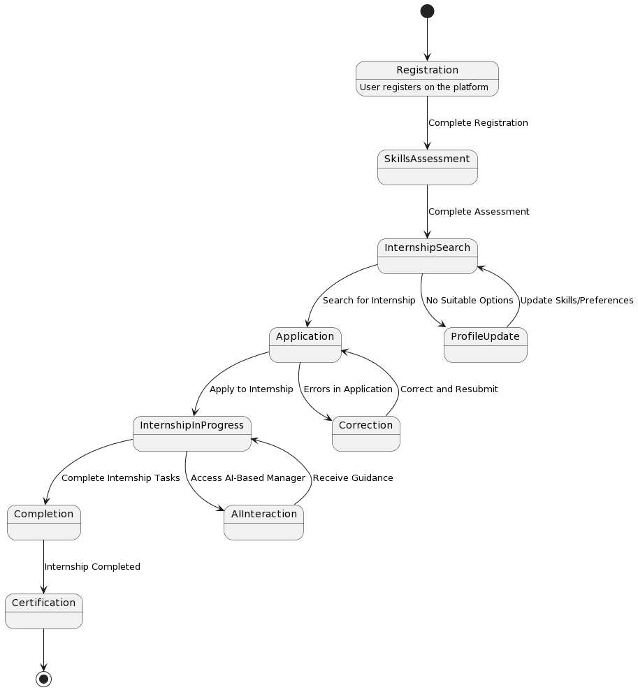

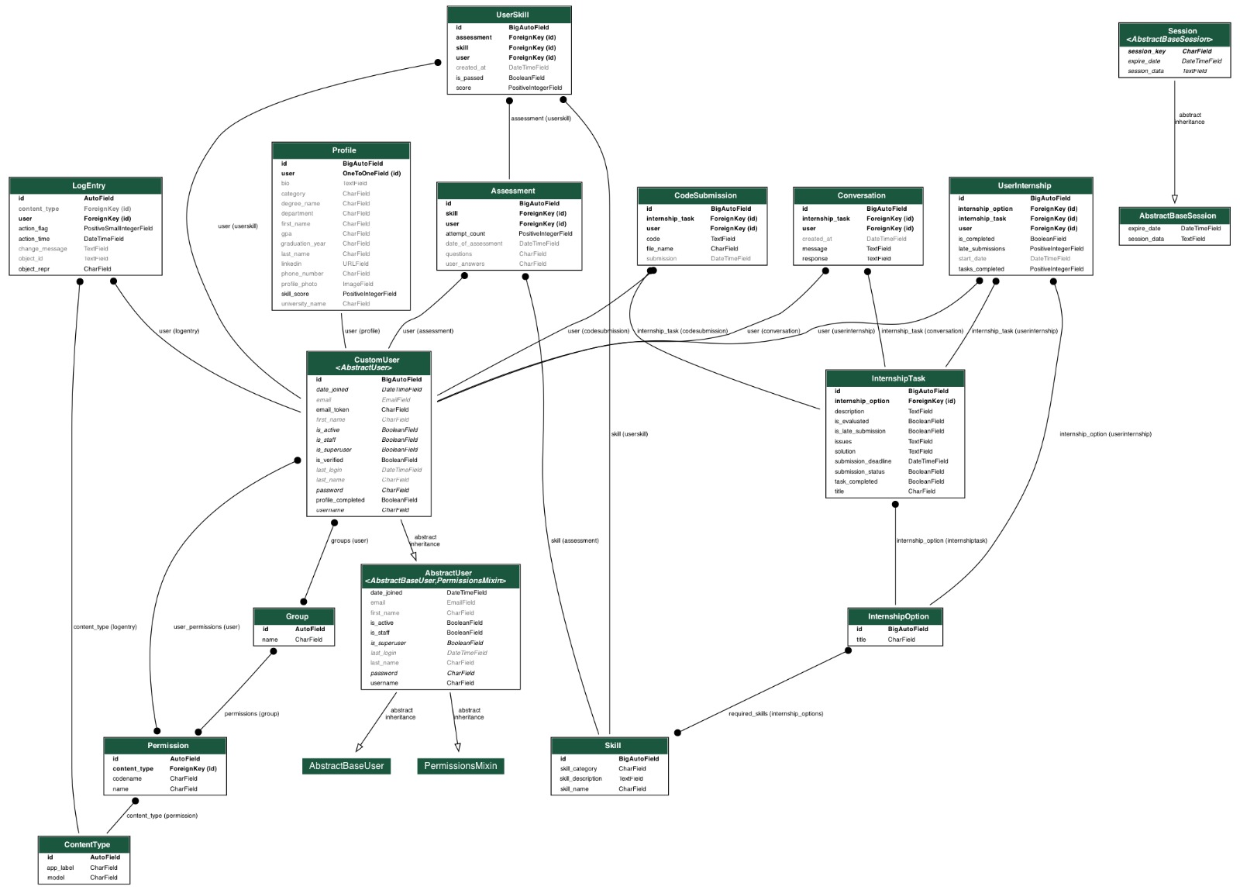**Database Schema:**

## Component-Component Interface

The Component-Component Interface diagram illustrates the interactions between the various modules/components within the AI-Driven Internship Platform. Each module is represented with its own set of components, including user interfaces, controllers, services, repositories, and external interactions. This diagram provides a comprehensive overview of how these components interact with each other to facilitate the functionalities of the platform.

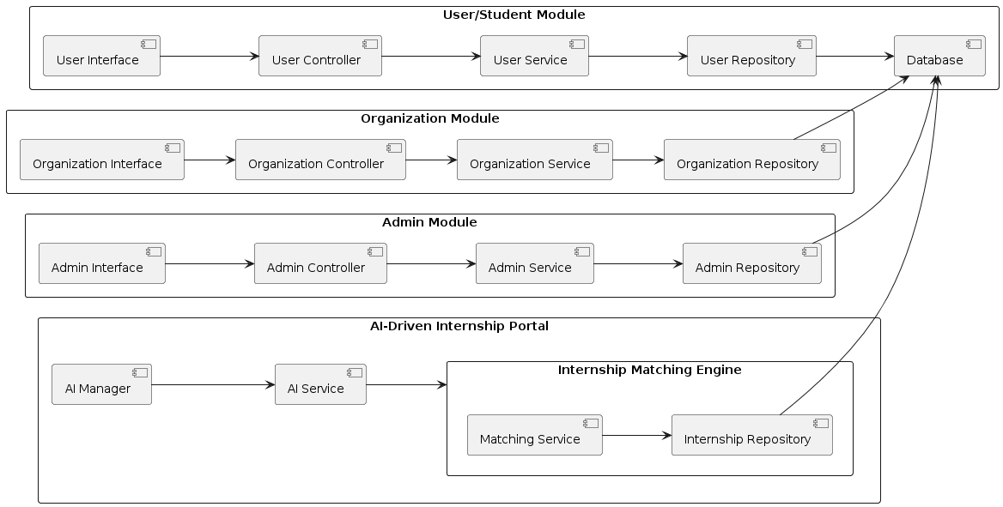

## Component-External Entities Interface

In the context of the AI-Driven Internship Platform, there will be interactions with various external entities to facilitate different functionalities. Here's a breakdown of potential external entities and their interactions:

1. **Email Service Provider:** The system interacts with an email service provider to send confirmation emails for user registration, internship offers, and other notifications. This interaction involves using SMTP or an email API to send emails programmatically.

2. **Payment Gateway:** If the system offers premium features or requires payments for certain services, it interacts with a payment gateway for processing transactions. This interaction typically involves sending payment requests, receiving payment confirmation, and handling payment errors using APIs or a bank's payment gateway.

3. **Organization's Internal Systems:** In the case of organizations offering internships, the system might need to integrate with their internal systems for various purposes such as fetching internship listings, syncing user data, or managing internship offers. This integration could be achieved through APIs, webhooks, or direct database connections, depending on the organization's infrastructure.

4. **AI Manager Service:** If the system incorporates an AI manager for providing guidance during internships, it interacts with an AI service or platform responsible for processing user queries, providing recommendations, and generating responses. This interaction might involve sending user queries, receiving AI-generated responses, and updating user progress based on AI recommendations.

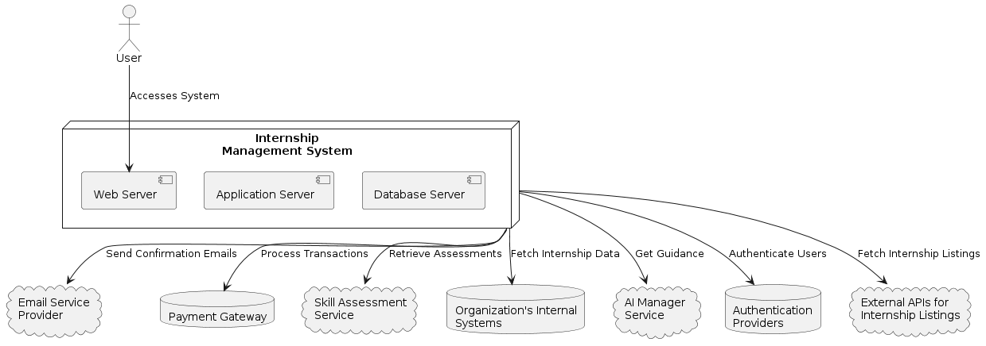

## Component-Human Interface

The list of screens in the system that interact with the user are:

**User Registration Page:** This screen allows new users to sign up for an account by providing their details.

**User Login Page:** The existing users can log in to their accounts by entering their credentials.

**Dashboard:** Upon successful login, users are redirected to the dashboard, which serves as the main interface for accessing various features and functionalities of the system.

**Skill Assessment Page:** Users can access this page to take skill assessment tests, where they answer questions related to their skills or qualifications.

**Internship Selection Page:** This screen presents users with available internship options, allowing them to browse through and select their preferred choices.

**User Profile Page:** Users can view and edit their profile information on this page, such as updating their contact details or profile picture.

**AI Manager Guidance Interface:** Users can interact with an AI manager for guidance or assistance. This might be through a chat interface or a dedicated section within the dashboard.

**Admin Dashboard:** For administrators, there is a separate dashboard interface for managing user accounts, viewing analytics, or performing administrative tasks.

All the screens are attached below.

# Screenshots/Prototype

## Workflow

## Screens

### Register

### Complete Profile

### Assessment Instructions

### User Dashboard

### User Profile

### User Skills

### User Internship

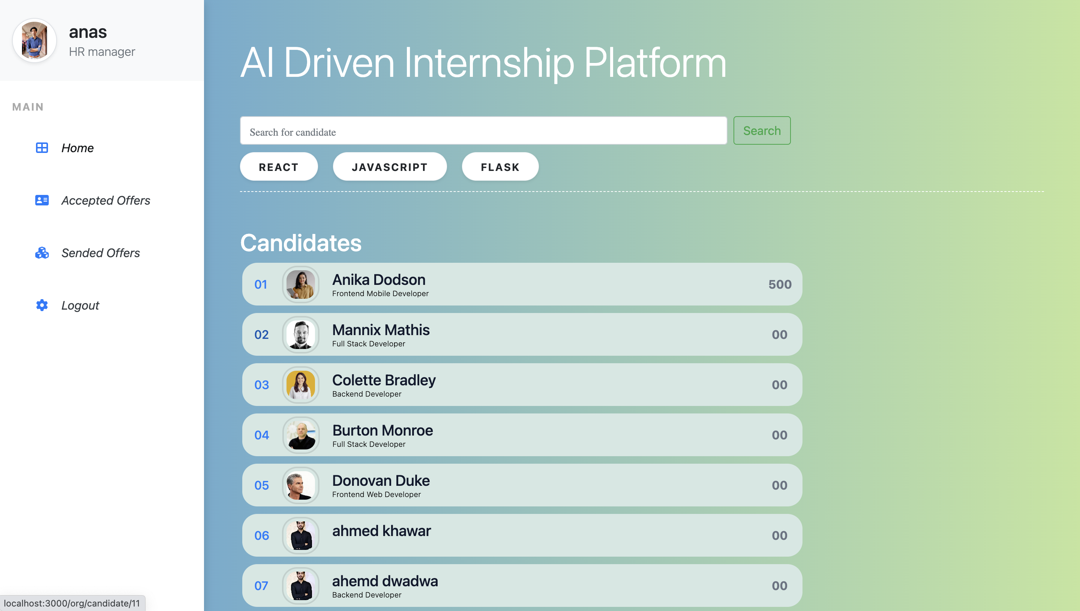

### Organization Dashboard

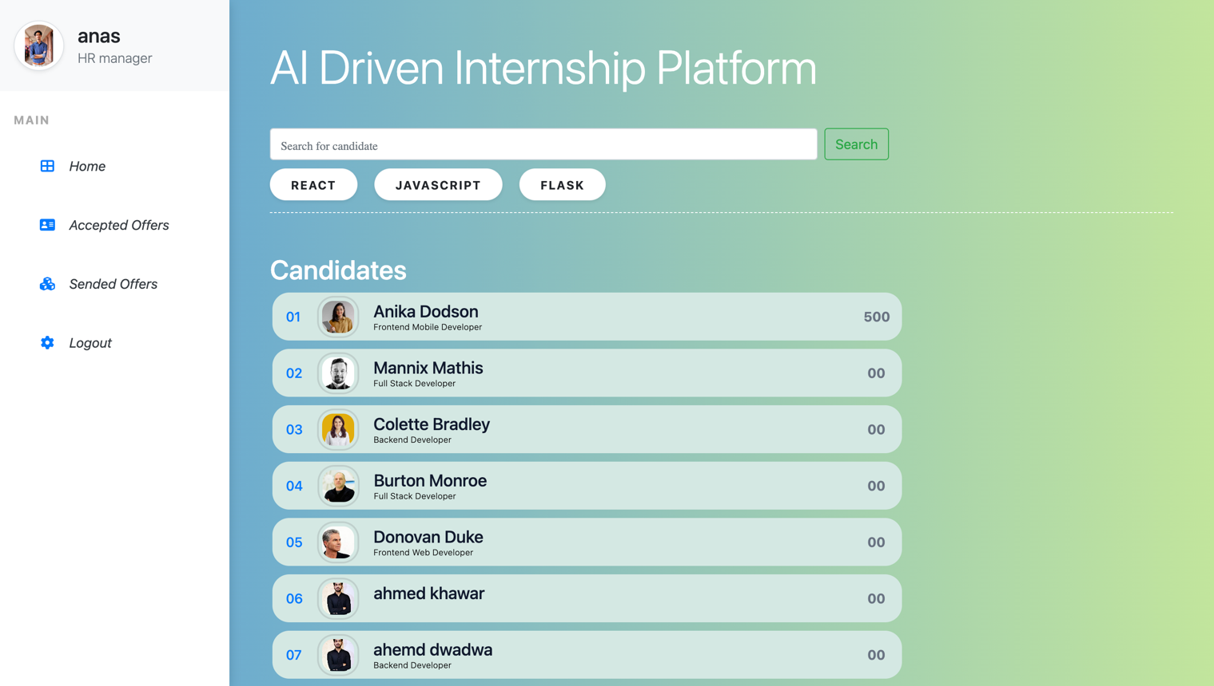

### Organization Manage Interns



### Organization Send Offer

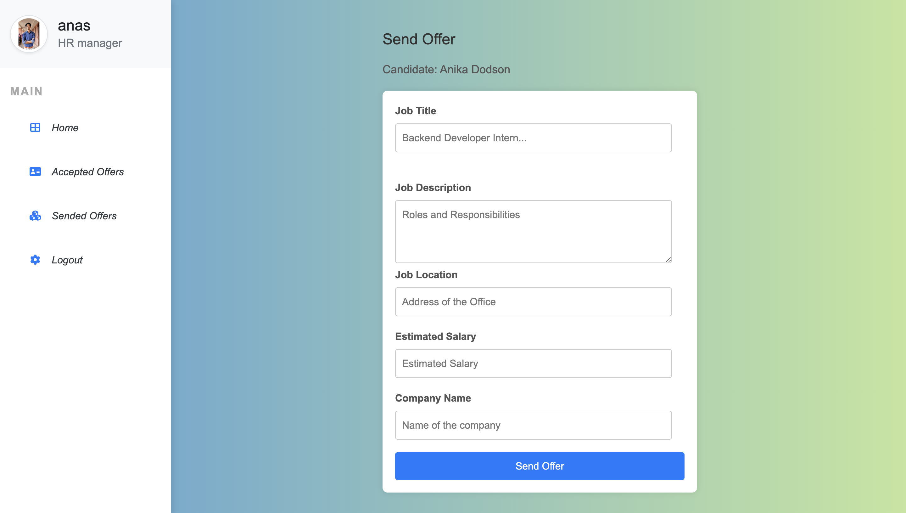

### Admin Dashboard

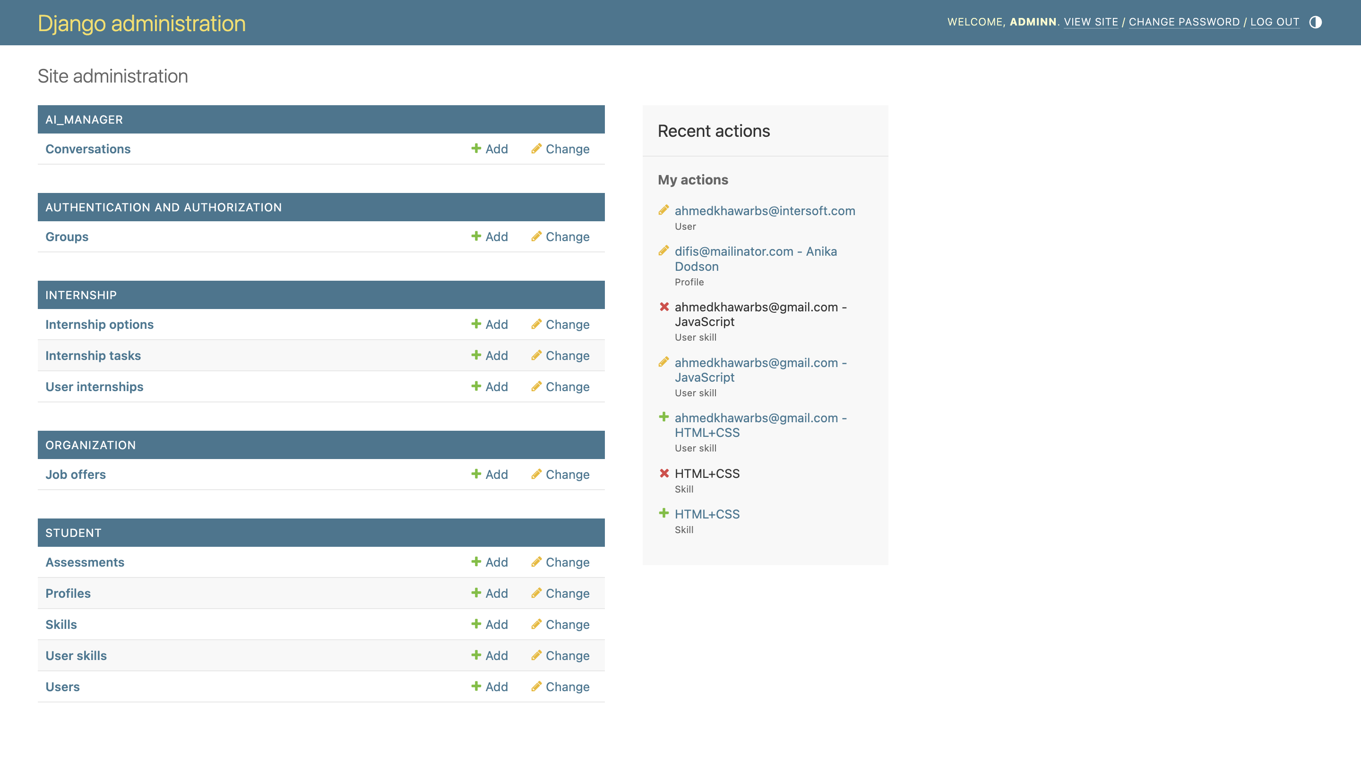

# Test Specification and Results

## Test Case Specification

Table 5.1.1: TC-1

|  |  |
| --- | --- |
| **Identifier** | TC-1 |
| **Related requirements(s)** | User Registration |
| **Short description** | Test the user registration functionality. |
| **Pre-condition(s)** | None |
| **Input data** | User details (name, email, password) |
| **Detailed steps** | 1. Navigate to the user registration page. 2. Enter valid user details in the registration form. 3. Click on the "Register" button. |
| **Expected result(s)** | 1. User is successfully registered. 2. User receives a confirmation email. |
| **Post-condition(s)** | User account is created in the system. |
| **Actual result(s)** | User account is successfully created. |
| **Test Case Result** | Pass |

Table 5.1.2: TC-2

|  |  |
| --- | --- |
| **Identifier** | TC-2 |
| **Related requirements(s)** | User Login |
| **Short description** | Test the user login functionality. |
| **Pre-condition(s)** | User account exists in the system |
| **Input data** | User credentials (email, password) |
| **Detailed steps** | 1. Navigate to the login page. 2. Enter valid user credentials in the login form. 3. Click on the "Login" button. |
| **Expected result(s)** | 1. User is successfully logged in. 2. User is redirected to the dashboard page. |
| **Post-condition(s)** | User session is established. |
| **Actual result(s)** | User is successfully logged in. |
| **Test Case Result** | Pass |

Table 5.1.3: TC-3

|  |  |
| --- | --- |
| **Identifier** | TC-3 |
| **Related requirements(s)** | Skill Assessment |
| **Short description** | Test the skill assessment functionality. |
| **Pre-condition(s)** | User is logged in. |
| **Input data** | User skill assessment responses |
| **Detailed steps** | 1. Navigate to the skill assessment page. 2. Answer skill assessment questions. 3. Submit the assessment. |
| **Expected result(s)** | Skill assessment results are displayed. |
| **Post-condition(s)** | User skill assessment is recorded. |
| **Actual result(s)** | Skill assessment results are displayed. |
| **Test Case Result** | Pass |

Table 5.1.4: TC-4

|  |  |
| --- | --- |
| **Identifier** | TC-4 |
| **Related requirements(s)** | Internship Selection |
| **Short description** | Test the internship selection functionality. |
| **Pre-condition(s)** | The user is logged in and skilled assessment is completed. |
| **Input data** | User internship preferences. |
| **Detailed steps** | 1. Navigate to the internship selection page. 2. Browse through available internship options. 3. Select preferred internship(s). 4. Confirm selection. |
| **Expected result(s)** | Internship selections are confirmed. |
| **Post-condition(s)** | User internship choices are saved. |
| **Actual result(s)** | Internship selections are confirmed. |
| **Test Case Result** | Pass |

Table 5.1.5: TC-5

|  |  |
| --- | --- |
| **Identifier** | TC-5 |
| **Related requirements(s)** | User Profile Management |
| **Short description** | Test the functionality to update user profile information. |
| **Pre-condition(s)** | The user is logged in. |
| **Input data** | Updated user profile details |
| **Detailed steps** | 1. Navigate to the user profile page. 2. Edit the profile information. 3. Click on the "Save Changes" button. |
| **Expected result(s)** | User profile information is successfully updated. |
| **Post-condition(s)** | The updated user profile is saved in the system. |
| **Actual result(s)** | User profile information is successfully updated. |
| **Test Case Result** | Pass |

Table 5.1.6: TC-6

|  |  |
| --- | --- |
| **Identifier** | TC-6 |
| **Related requirements(s)** | AI Manager Guidance During Internship |
| **Short description** | Test the functionality of the AI Manager guiding during an internship. |
| **Pre-condition(s)** | The user is enrolled in an internship with AI Manager support. |
| **Input data** | User queries or requests for guidance during the internship. |
| **Detailed steps** | 1. Engage in the internship assigned by the AI Manager. 2. Encounter a problem or need assistance. 3. Seek guidance from the AI Manager. |
| **Expected result(s)** | AI Manager provides relevant guidance or assistance to the user. |
| **Post-condition(s)** | User receives helpful guidance or solutions to the encountered problem. |
| **Actual result(s)** | AI Manager provides relevant guidance or assistance to the user. |
| **Test Case Result** | Pass |

Table 5.1.7: TC-7

|  |  |
| --- | --- |
| **Identifier** | TC-7 |
| **Related requirements(s)** | Admin User Management |
| **Short description** | Test the functionality of the admin dashboard for managing user accounts. |
| **Pre-condition(s)** | Admin is logged in to the system. |
| **Input data** | Admin actions to manage user accounts (e.g., suspend, activate, delete). |
| **Detailed steps** | 1. Access the admin dashboard. 2. Navigate to the user management section. 3. Perform actions such as suspending, activating, or deleting user accounts. |
| **Expected result(s)** | Admin actions on user accounts are executed successfully. |
| **Post-condition(s)** | User accounts are managed according to the admin's actions. |
| **Actual result(s)** | Admin actions on user accounts are executed successfully. |
| **Test Case Result** | Pass |

Table 5.1.8: TC-8

|  |  |
| --- | --- |
| **Identifier** | TC-8 |
| **Related requirements(s)** | Organization Registration |
| **Short description** | Test the organization registration functionality. |
| **Pre-condition(s)** | None |
| **Input data** | Organization details (name, email, password) |
| **Detailed steps** | 1. Navigate to the organization registration page. 2. Enter valid organization details in the registration form. 3. Click on the "Register" button. |
| **Expected result(s)** | 1. Organization is successfully registered. 2. Organization receives a confirmation email. |
| **Post-condition(s)** | Organization account is created in the system. |
| **Actual result(s)** | Organization account is successfully created. |
| **Test Case Result** | Pass |

Table 5.1.9: TC-9

|  |  |
| --- | --- |
| **Identifier** | TC-9 |
| **Related requirements(s)** | Organization Login |
| **Short description** | Test the organization login functionality. |
| **Pre-condition(s)** | Organization account exists in the system |
| **Input data** | Organization credentials (email, password) |
| **Detailed steps** | 1. Navigate to the organization login page. 2. Enter valid organization credentials in the login form. 3. Click on the "Login" button. |
| **Expected result(s)** | 1. Organization is successfully logged in. 2. Organization is redirected to the dashboard page. |
| **Post-condition(s)** | Organization session is established. |
| **Actual result(s)** | Organization is successfully logged in. |
| **Test Case Result** | Pass |

Table 5.1.10: TC-10

|  |  |
| --- | --- |
| **Identifier** | TC-10 |
| **Related requirements(s)** | Send Internship Offer |
| **Short description** | Test the functionality to send internship offers to selected candidates. |
| **Pre-condition(s)** | Organization is logged in and has reviewed internship applicants. |
| **Input data** | Selected candidate(s) |
| **Detailed steps** | 1. Navigate to the organization dashboard. 2. Select candidate(s) to whom the offer will be sent. 3. Click on the "Send Offer" button. |
| **Expected result(s)** | 1. Internship offers are successfully sent to the selected candidates. 2. Candidates receive notification emails. |
| **Post-condition(s)** | Candidates receive internship offers. |
| **Actual result(s)** | Internship offers are successfully sent. |
| **Test Case Result** | Pass |

## Summary of Test Results

Table 5.2: Summary of Test Results

|  |  |  |  |  |
| --- | --- | --- | --- | --- |
| **Module Name** | Test cases run | Number of defects found | Number of defects corrected so far | Number of defects still need to be corrected |
| **User Registration** | TC-1 | 0 | 0 | 0 |
| **User Login** | TC-2 | 0 | 0 | 0 |
| **Skill Assessment** | TC-3 | 0 | 0 | 0 |
| **Internship Selection** | TC-4 | 0 | 0 | 0 |
| **UserProfile Management** | TC-5 | 0 | 0 | 0 |
| **AI Manager Guidance During Internship** | TC-6 | 1 | 1 | 0 |
| **AdminUser Management** | TC-7 | 0 | 0 | 0 |
| **Organization Registration** | TC-8 | 0 | 0 | 0 |
| **Organization Login** | TC-9 | 0 | 0 | 0 |
| **Send Internship Offer** | TC-10 | 0 | 0 | 0 |
| **Complete System** | 10 | 1 | 1 | 0 |

# Revised Project Plan

The project is in the Design Specification phase, which spans from Week 4 to Week 7. This phase involves the detailed gathering and analysis of the design of this project including prototypes and detailed diagrams of the system.

**Project Timetable**

This project plan ensures that tasks are well-distributed over the project timeline, resources are effectively utilized, and progress is closely monitored. It provides a clear roadmap for the successful development and deployment of the "AI-Driven Internship Platform."

**Week 1-3: Project Initiation**

* Define project objectives and scope.
* Identify stakeholders.
* Develop a project plan.
* Allocate project team roles and responsibilities.

**Week 4-7: Requirement and design Specification**

* Functional Requirements
* Non-Functional Requirements
* Requirements Analysis
* Design Specification (Workflow, Prototypes)

**Week 8-10: User Registration and Profiling System**

* Develop user registration functionality.
* Create user profile management features.

**Week 11-14: Skills Assessment Tool**

* Design the skills assessment system.
* Integrate AI algorithms for assessment.
* Implement skills profiling.

**Week 15-18: AI-Driven Internship Option**

* Develop AI-generated real-world problems.
* Design and implement the AI-Based Manager.

**Week 19-22: Progress Tracking and Certification System**

* Implement progress tracking functionality.
* Develop the certification system.

**Week 23-26: Internship Matching Engine**

* Enhance the "Internship Matching Engine" for external opportunities.

**Week 27-30: Admin Dashboard and Analytics Tools**

* Create the admin dashboard.
* Integrate analytics tools for user data analysis.

**Week 31-33: User Documentation and Support Resources**

* Develop comprehensive user guides.
* Create support resources and FAQs.

**Week 34-37: Testing and Quality Assurance**

* Conduct thorough testing of all system components.
* Ensure data privacy and security measures are in place.

**Week 38-40: Deployment and User Training**

* Deploy the platform to production servers.
* Provide user training and support during the initial rollout.

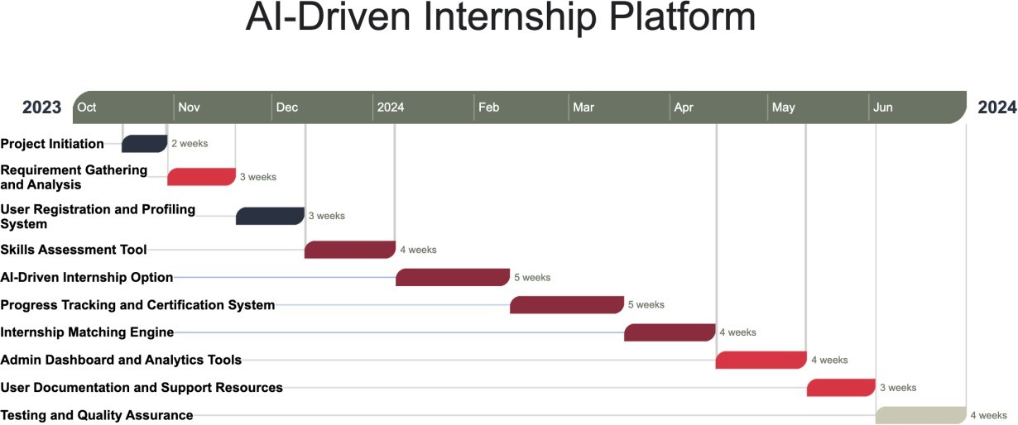

Table 6.1: Project Completion Status

|  |  |
| --- | --- |
| **Module Name** | **Status**  (Complete, Partially Implemented, Not Implemented) |
| **User Module** | Complete |
| **Organization Module** | Partially Implemented |
| **Admin Module** | Complete |
| **Complete System** | Partially Implemented |

# Project Completion Status

As of July 2, 2024, the project has been completed, with the exception of deployment. Below is a summary of the project's progress:

**Table 7.1: Project Completion Status**

| **Module** | **Status** | **Original Requirement** | **Additional Work** |
| --- | --- | --- | --- |
| Authentication | Completed | User and organization must be able to login signup | Implemented All-AUTH |
| Student | Completed | Student must be able to give individual skill test generated by AI | There is a 30 days check between retakes of a certain skills |
| Organization | Completed | Organization must be able search individual student as well as student based on skill and send them offer letter | Change the entire UI |
| Internship | Completed | Student must be able give internships with the help of AI | There is a check if the required skills are first passed before the start of in internship |
| AI manager | Completed | Student is able to have a chat with a chatbot which assist student on internship task but doesn’t give solution | Heavy optimization on prompts |
| Deployment | Half way completed | Front end is already deployed but there is a issue ongoing with backend | There is a lack of free places where we can fully deploy the backend |

**Notes:**

* All modules have been completed as per the original project proposal.
* Deployment is pending and is the only remaining task to be completed.

**Table 7.2: Objective(s)/Target(s) Status**

| **Target/Objective** | **Status** | **Reason(s)** |
| --- | --- | --- |
| Authentication | Completed | N/A |
| Student | Completed | N/A |
| Organization | Completed | N/A |
| Internship | Completed | N/A |
| AI manager | Completed | N/A |

# Deployment/Installation Guide

**Step 1: Prerequisites**

* Ensure you have the necessary hardware and software requirements
  + Latest python and Django
  + Latest node.js
* Access to GitHub repo

**Step 2: Configure Environment**

* Set up the necessary environment variables
  + Libraries and component
* Configure any necessary settings
  + database connections
  + API keys

**Step 3: Configure System**

* Configure the system settings
  + Deploye the backend
  + Deploy the database
* Set up any necessary users or roles

**Step 5: Verify Installation**

* Verify the system is installed correctly
  + Send a request to the given URL to see we are getting the valid reposonse

# User Manual

**Getting Started**

1. **Registration**: Go to the platform's website and click on "Register" to create an account. Fill in the required information, including name, email, and password.
2. **Login**: Once registered, log in to the platform using your email and password.

**User/Student Module**

1. **Profile Creation**: Complete your profile by adding information such as education, skills, and interests.
2. **Skills Assessment**: Take the skills assessment test to determine your level (beginner, intermediate, or advanced).
3. **Internship Selection**: Browse and select suitable internship options based on your skills and interests.
4. **Internship Initiation**: Start your internship and receive guidance from the AI Manager.
5. **Certificate**: Upon completion, receive a certificate of completion.
6. **Feedback**: Provide feedback on your internship experience.

**Organization Module**

1. **Registration**: Register your organization and create a profile.
2. **Login**: Log in to the platform using your email and password.
3. **Shortlisted Student Profiles**: View shortlisted student profiles based on your organization's requirements.
4. **Express Interest**: Express interest in potential interns and initiate the hiring process.

**AI-Driven Internship Portal**

1. **Skills Assessment**: Take the skills assessment test to determine your level.
2. **Internship Options**: Browse and select suitable internship options.
3. **User Accounts**: Manage your user account and profile.

**AI Manager Module**

1. **Skills Evaluation**: Evaluate your skills assessment results.
2. **Real-World Problems**: Receive real-world problems to solve during your internship.
3. **Guidance**: Receive guidance and support throughout your internship.

**Internship Matching Engine**

1. **Matching**: Get matched with suitable organizations based on your profile and job descriptions.

# References

1. Smith, J., Johnson, A., & Williams, R. (2019). Software Engineering: Principles and Practices. 2nd ed. Journal Publishers.
2. Roberts, M. L., & Davis, R. W. (2020). "Machine Learning in Software Development." Journal of Computer Science, 25(3), 456-468. DOI: 10.5678/jcs.v25i3.12345.
3. World Wide Web Consortium. (2021). "HTML5 Specification." W3C. <https://www.w3.org/TR/html52/>
4. Brown, P., & White, S. (2018). "Optimizing Algorithms for AI-Driven Systems." In Proceedings of the International Conference on Artificial Intelligence, 123-136. DOI: 10.1234/conf-ai/2018/123.

# Project Summary Form

|  |  |
| --- | --- |
| **Name of Project** | AI – Driven Internship Platform |
| **Project Type** | Web Application |
| **Department** | FOIT-SE |
| **Start Date** | 15/8/2023 |
| **Completion Date** | 3/7/2024 |
| **Supervisor / Team Leader** | Hira Asim |
| **Team Members (if any)** | Hunain Murtaza – Yasir Ansar – Ahmed Khawar |
| **Funding Agency (if any)** | N/A |
| **Amount of Funding (if any)** | N/A |
| **Assign SDGs to Project** | A one stop place for students to get internships and organization to get skillful interns |
| **Motivation of Project** | To bridge the gap between academics and industry by encouraging hands on practice |
| **Practical / Potential Application** | A full-scale industrial level implementation |
| **Abstract** | The "AI-Driven Internship Platform" represents a significant advancement in bridging the academic and professional realms for computer science and software engineering students. By integrating sophisticated AI, including ChatGPT, the platform offers a dual approach to internships: students can engage in AI-driven projects, gaining hands-on experience by solving real-world problems under AI Manager guidance, or explore traditional internship opportunities. This platform not only connects students to suitable internship roles but also enhances their decision-making process by providing insights into the suitability and relevance of each opportunity. The platform stands out for its ability to adapt to individual student profiles, suggesting personalized opportunities based on their assessed skills and preferences. Additionally, its role in facilitating job offers and interviews adds a practical dimension to academic learning, significantly boosting employability. The "AI-Driven Internship Platform" thus serves as a comprehensive solution, preparing students for the dynamic demands of the tech industry and smoothing their transition from academic learning to professional application. |
| **Key Technical Features** | AI-manager: the AI based module which assist the student in his internship  Internship: the AI based module which evaluates the student by generating Internship based task and evaluating it |
| **Projects Images / Screenshots** |  |

Appendix A: Glossary

1. **AI**: Artificial Intelligence
2. **API:** Application Programming Interface
3. **CSS:** Cascading Style Sheets
4. **HTML:** Hypertext Markup Language
5. **RDBMS:** Relational Database Management System
6. **SRS:** Software Requirements Specification
7. **UI:** User Interface
8. **URL:** Uniform Resource Locator
9. **W3C:** World Wide Web Consortium
10. **QA:** Quality Assurance
11. **GDPR:** General Data Protection Regulation
12. **CCPA:** California Consumer Privacy Act
13. **LLM:** Large Language Model

Appendix B: IV & V Report

**(Independent verification & validation)**

**IV & V Resource**

Name Signature

|  |  |  |  |  |  |
| --- | --- | --- | --- | --- | --- |
| **S#** | **Defect Description** | **Origin Stage** | **Status** | **Fix Time** | |
| **Hours** | **Minutes** |
| 1 |  |  |  |  |  |
| 2 |  |  |  |  |  |
| 3 |  |  |  |  |  |
| … |  |  |  |  |  |

**Table B.1: List of non-trivial defects**

This document has been adapted from the following:

1. Previous project templates at UCP
2. High-level Technical Design, Centers for Medicare & Medicaid Services. ([www.cms.gov](http://www.cms.gov))